Program Structures and Algorithms
Spring 2025
Team Project: MCTS

Team member:
NAME: Yuyang Wang
NUID: 002310874
Github link: https://github.com/NEU-Yuyang7/DSAIPG
NAME: Jiajun Zheng
NUID: 002305427
Github:
https://github.com/jjMurphy1012/INFO6205/tree/editionFirst/src/it/java/com/phasmidsoftware/dsaipg/projects

- Tic-tac-toe
  - Executive Summary
We successfully implemented the Monte Carlo Tree Search (MCTS) algorithm for the Tic-Tac-Toe game. The algorithm features selection using UCT, expansion, simulation, and backpropagation. The final output provides the predicted winner based on multiple simulations, showcasing our understanding of tree search techniques in turn-based games.

  - Unit tests
Test Design for PositionTest shown as Figure 1.
The Position class represents the game board and encapsulates logic for moves, board transformations, winning condition evaluation, and string rendering.
Key Testing Points:
parsePosition(): Ensure the board string is correctly parsed into a 2D grid and returns the correct number of available moves for the next player.
move(): Validate that legal moves return a new board state and switch players; illegal moves (e.g., two consecutive moves by the same player) throw an exception.
moves(): Confirm it returns the correct list of empty cells representing available positions.
rotate(): Verify that the board correctly rotates 90 degrees clockwise, matching expected output.
reflectRow(): Ensure the board correctly reflects horizontally (row-wise) and matches the expected mirrored state.
reflectColumn(): Ensure the board correctly reflects vertically (column-wise) and matches the expected mirrored state.
threeInARow(): Detect winning configurations with three marks aligned, both horizontally and diagonally.
winner(): Confirm that the game accurately identifies the winning player based on current board state.
full(): Verify the board accurately identifies when all cells are filled (i.e., a draw).
equals() / hashCode(): Ensure logically equivalent board states are treated as equal and produce identical hash codes.
render(): Confirm the board’s string representation matches the expected human-readable format.
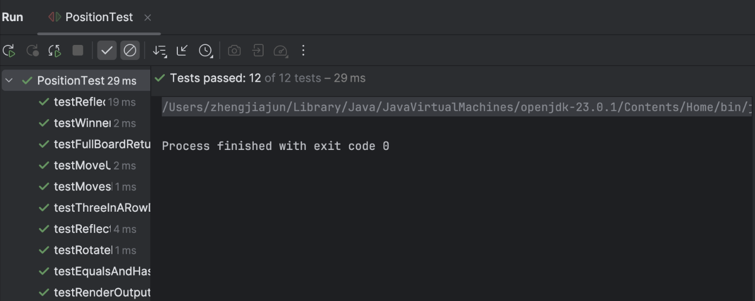
Figure 1. Screenshot of PositionTest.
Test Design for TicTacToeNodeTest shown as Figure 2.
The TicTacToeNode class represents a game state node in the MCTS search tree for TicTacToe. These unit tests validate terminal state detection, playout tracking, score backpropagation, and tree structure correctness.
Key Testing Points:
leafNode on terminal win: Confirm that a node where player X has won is recognized as a terminal leaf. The playout count is 1, and the win count is correctly set to 2, following the win-scoring convention.
leafNode on draw: Validate that a fully filled board resulting in a draw is treated as terminal. Playouts = 1, and wins = 1 (neutral scoring for draws).
non-leaf node on initial state: Ensure a fresh game board is not terminal, and both playouts and wins are initialized to 0.
addChild and backpropagate: Test the expansion of child nodes and the proper accumulation of their stats into the parent. Validates that MCTS updates are correctly propagated up the tree.
parent linking: Verify that each child node maintains a reference to its parent, ensuring correct upward traversal and score updates.
white(): Check that the method correctly identifies the root player as X (White). Supports player-based logic like score inversion in the MCTS process.
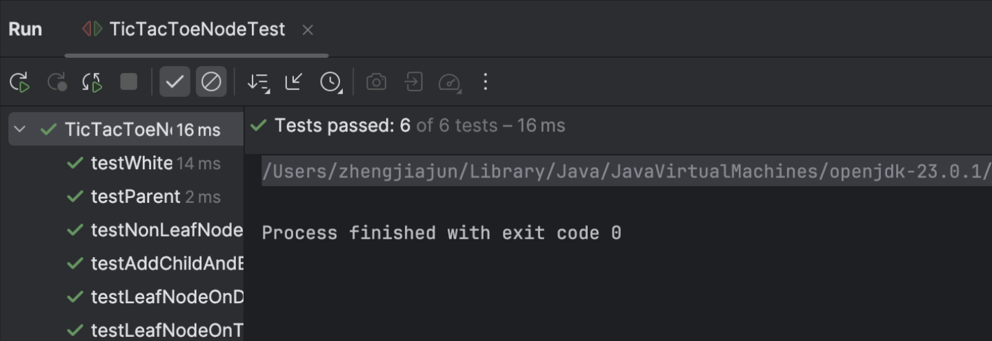
Figure 2. Screenshot of TicTacToeNodeTest.
Test Design for TicTacToeTest shown as Figure 3.
The TicTacToe class manages game state, player turns, and win/draw conditions. These tests ensure the game's core logic—state transitions, move validation, and outcome detection—is correctly implemented.
Key Testing Points:
initialStateIsNotTerminal(): Ensure the game starts in a non-terminal state, allowing moves from the beginning.
initialPlayerIsX(): Verify that player X is always assigned as the starting player, per standard TicTacToe rules.
nextState(): Confirm that making a move updates the board and switches the current player from X to O.
fullBoardIsTerminal(): Validate that a fully filled board is correctly recognized as a terminal (end) state.
winningStateReturnsWinner(): Check that when player X completes a winning row, the correct winner is returned.
moves(): Ensure that a new game state provides all 9 positions as valid move options.
toString(): Confirm that converting the game state to a string executes safely and is useful for debugging or display purposes.

Figure 3. Screenshot of TicTacToeTest.
Test Design for MCTSTest shown as Figure 4.
The MCTSTest class verifies the core behavior and stability of the Monte Carlo Tree Search (MCTS) algorithm in the context of a TicTacToe game simulation.
Key Testing Points:
runMCTS(100): Ensure the algorithm runs with 100 simulations without throwing any exceptions (basic execution safety).
bestChild() after 200 simulations: Validate that a non-null best move is returned, confirming correct tree expansion and selection logic.
Game reaches terminal state: After running MCTS, the game should play to completion with valid moves, ending in a win or draw (state transition correctness).
Multiple MCTS runs: Confirm that repeated calls to the algorithm consistently return a valid best move, ensuring algorithmic stability and determinism.
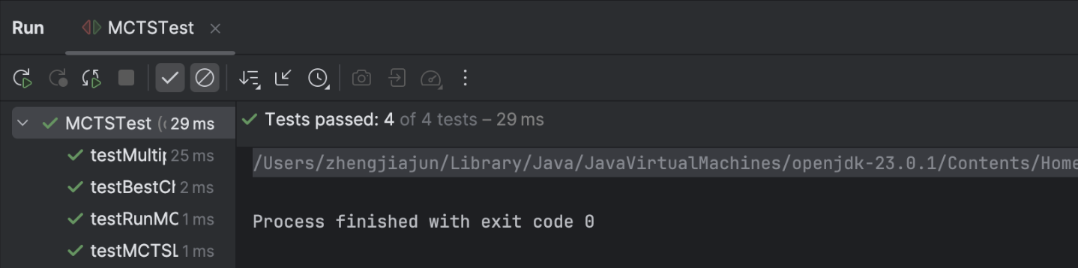
Figure 4. Screenshot of MCTSTest.

- Blackjack
  - Executive Summary
This project implements a simplified Blackjack game simulator, and an AI agent based on Monte Carlo Tree Search (MCTS) for decision optimization.
The simulation models a standard one-player-vs-dealer Blackjack scenario. Each MCTS state includes the player's hand, dealer's visible hand, and the remaining undealt deck. Unlike traditional fixed sequence dealing, the deck randomly selects cards from the remaining pool, ensuring diverse simulation paths.
The MCTS agent follows the standard four-phase procedure: selection, expansion, simulation, and backpropagation. The node selection uses the UCT formula, and simulation outcomes are scored as win (1.0), draw (0.5), or loss (0.0).
The goal is to evaluate and improve the effectiveness of MCTS in Blackjack environments under full information, and to provide a clean, testable baseline for future enhancements (e.g., improved policies, partial information models, or opponent modeling).

  - Simplified Game Rules
The game involves two participants: the Dealer and the Player. A standard deck of 52 cards is used, excluding Jokers. Each card from 2 to 10 is worth its face value. J, Q, and K are each worth 10 points. Aces (A) can be counted as either 1 or 11.
At the beginning of the game, the dealer and player take turns drawing two cards each. If a player reaches exactly 21 points on the initial deal, they win immediately. If both reach 21, the result is a draw.
Game Flow:
The Player goes first and may choose to Hit (draw a card) or Stand (end their turn). If the player's total exceeds 21, they bust and lose immediately. The Dealer then takes their turn using the same rules, but must continue hitting until reaching at least 17 points. Both hands are visible throughout the game.
Winning Conditions:
If the player busts, the dealer wins. If the dealer busts, the player wins. If neither busts, the hand with the higher point total wins. If both hands have the same total, it's a draw.

  - OOD
Based on the simplified Blackjack game rules and the Monte Carlo Tree Search (MCTS) decision-making mechanism, this system is designed following Object-Oriented Design (OOD) principles, emphasizing modularity and extensibility. The game features two types of players: the regular player and the dealer. The DealerPlayer class extends the Player class and overrides the action() method to enforce the rule that the dealer must Hit if the total score is less than 17. The regular player's actions—Hit or Stand—are decided dynamically via the MCTS strategy based on the current hand and the remaining cards in the deck.
The Deck class encapsulates a standard 52-card deck and provides key operations such as shuffle(), dealCard(), score(), isBusted(), and isBlackJack(). Each card is represented by the Card class, which includes a face value and a suit. A player's hand is modeled using a List<Card>, establishing a composition relationship.
In terms of class relationships: A Deck has-a collection of Card objects. A Player has a hand composed of Card instances. DealerPlayer is-a specialized form of Player, representing inheritance.
The Player class defines the core behavioral interface action(), which for regular players is executed by invoking the MCTS agent to determine whether to Hit or Stand. The DealerPlayer class overrides this method with a fixed rule-based policy.
The overall game flow is managed by the BlackJackGameSimulator, which handles deck initialization, the initial deal (two cards per player), evaluation of opening BlackJack conditions, the player's round, the dealer's round, and finally a comparison of scores if both parties Stand. This design ensures that each game component is logically encapsulated and maintains state isolation. The system structure supports future expansions such as graphical interfaces, enhanced AI strategies, or multiplayer support.
The OOD system architecture is illustrated in Figure 5.
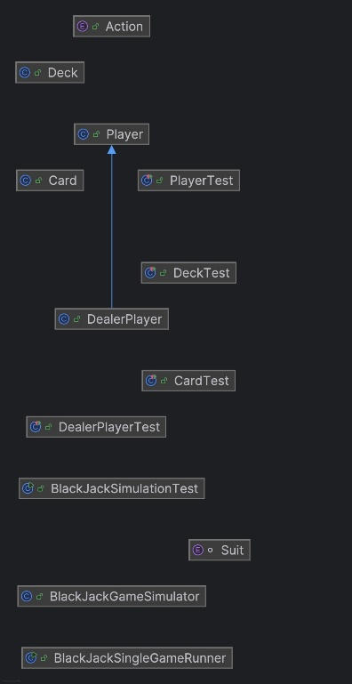
Figure 5. OOD system architecture
  - MCTS
At selection phase, starting from the root node, the algorithm uses the Upper Confidence Bound for Trees (UCT) formula to traverse the tree.
$$UCT=\frac{w_{i}}{n_{i}}+c\sqrt{\frac{\ln{N_{i}}}{n_{i}}}$$
The child with the highest UCT score is selected at each level, and this process continues until a leaf node is reached.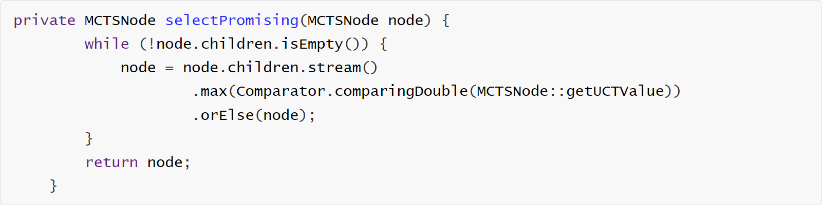
At expansion phase, if the selected node is not a terminal state, it is expanded by adding one or both of the following children: A node resulting from the player choosing Hit (drawing a random card from the remaining deck), A node resulting from the player choosing Stand. The node becomes fully expanded once both possible actions have been explored.
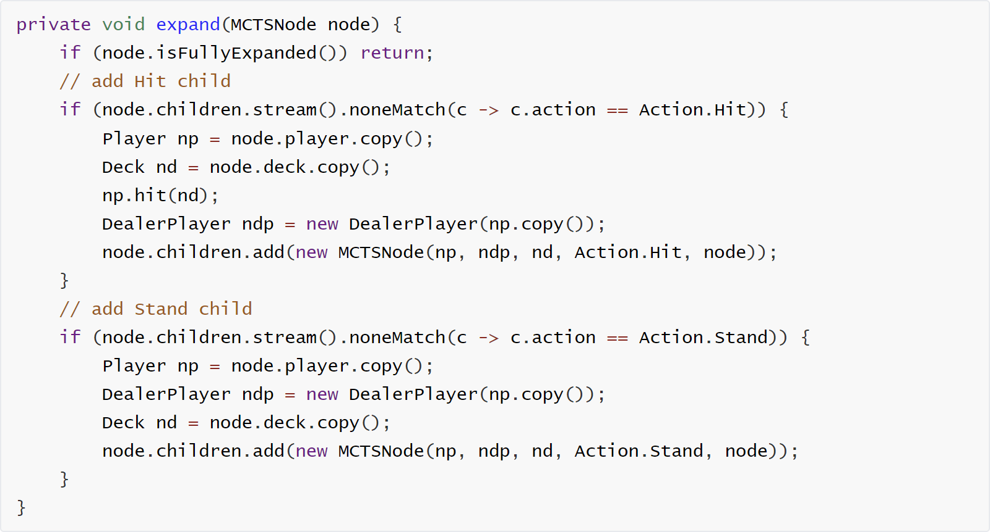
At simulation phase (Rollout), a random simulation is performed from the expanded node using the following steps:
The current game state (player hand, dealer hand, and remaining deck) is deep copied to avoid side effects. The player performs random actions. The dealer follows the fixed rule: must Hit if total score is below 17. The result of the game is evaluated, Win → 1.0, Draw → 0.5, Loss → 0.0. This reward is returned for backpropagation.
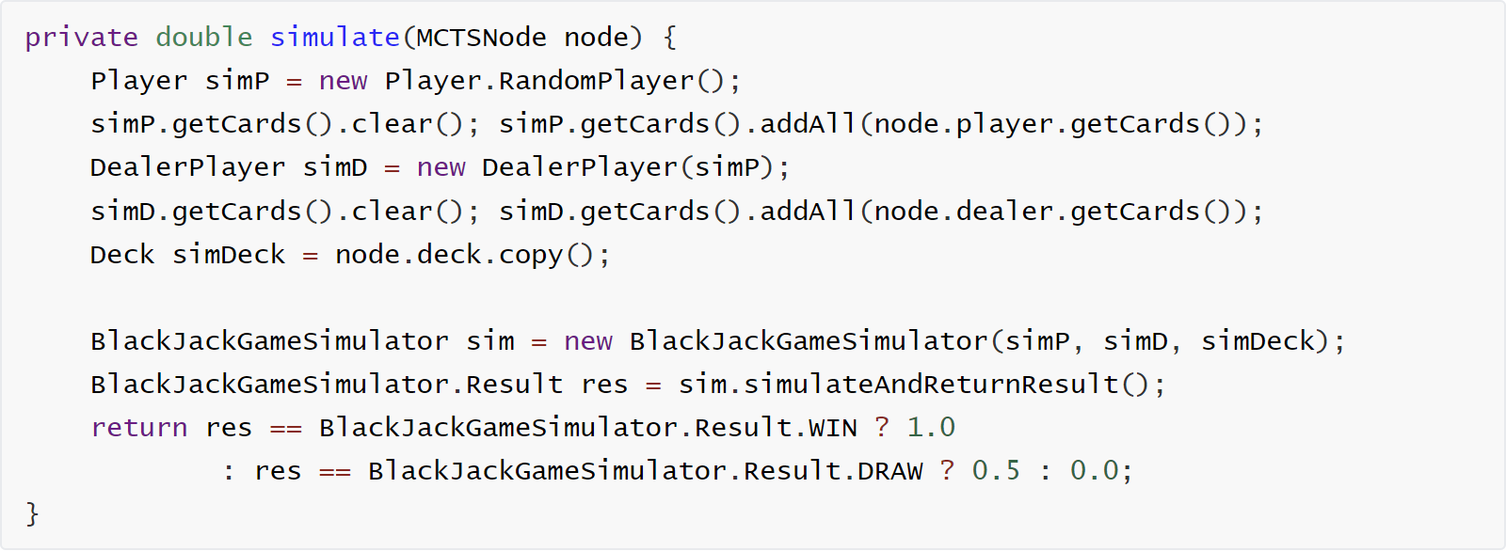
At backpropagation phase, the result of the simulation is propagated up the tree, incrementing the visits and wins counters for each node along the path from the simulated node back to the root.
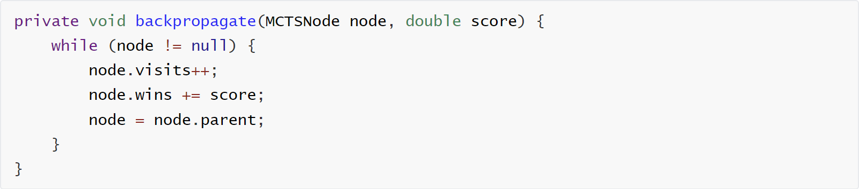

  - Unit tests
PlayerTest – Testing player behaviors and score logic. The result is shown as Figure 6.
Test Design Goals: Verify card-related behavior such as hit() adds a card. Validate the score() method handles various card combinations correctly, especially Aces. Confirm isBlackjack() works for initial two-card combinations. Check isBusted() returns true when score > 21. Ensure copy() method returns a shallow card copy that’s still valid.﻿
Covered Cases: Score with face cards and Aces as 1 or 11. Blackjack with A + face card. Busting with 3+ cards. copy() creates an identical, independent player object.
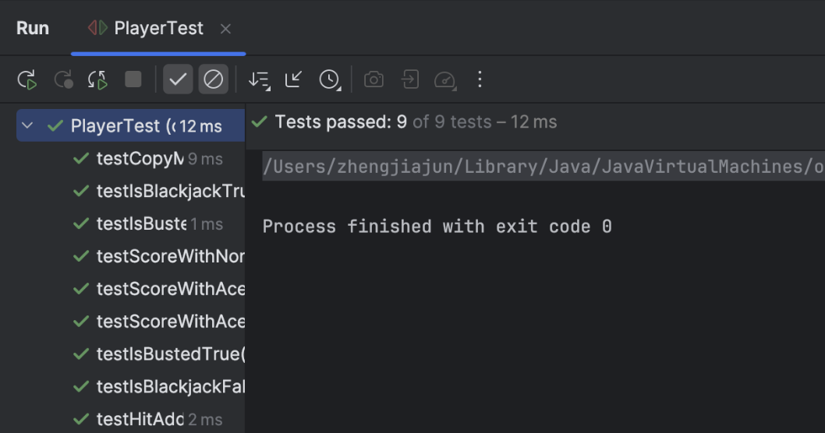
Figure 6. Screenshot of PlayerTest.
DeckTest – Testing deck integrity and behavior. The result is shown as Figure 7.
Test Design Goals: Ensure a newly created deck has 52 cards. Confirm dealCard() reduces the number of remaining cards. ﻿Ensure dealCard() throws an exception when the deck is empty. Validate that copy() creates an independent copy with same content.﻿ Confirm shuffle() changes the card order (within reason).
Covered Cases: Deck size management. Exception handling when depleted. State independence between copies. Shuffling randomness and functionality.
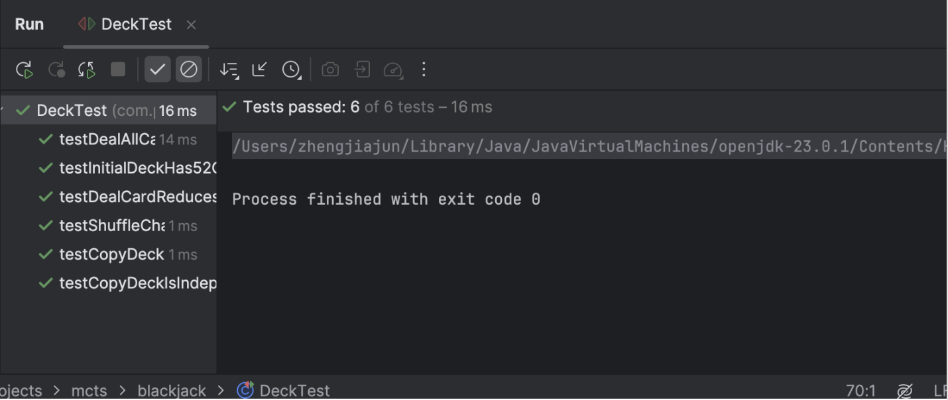
Figure 7. Screenshot of DeckTest.
CardTest – Testing individual card logic. The result is shown as Figure 8.
Test Design Goals: Check correct face values are returned by value(). Ensure isAce() and isFace() return accurate results. Confirm toString() produces expected readable string (e.g., "K of Spade"). Test compareTo() method for sorting or score-related logic.
Covered Cases:
Various face values: Ace, 2–9, 10–13. String output verification. Card comparison based on value.
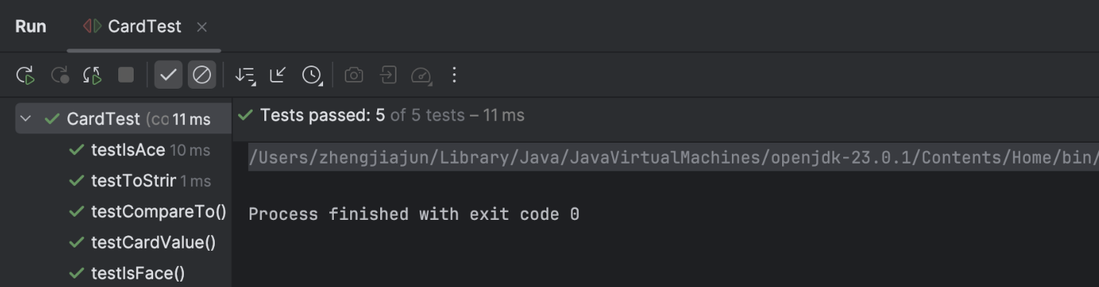
Figure 8. Screenshot of CardTest.
DealerPlayerTest – Testing dealer AI and policy. The result is shown as Figure 9.
Test Design Goals: Ensure dealer follows the rule: hit if score < 17, otherwise stand. Test copy() behavior for dealer/player separation. Use reflection to verify the opponent is reassigned correctly.
Covered Cases: Behavior change at score thresholds (16 vs 17). Functional correctness of the copy() method. Internal field correctness (via reflection for private field opponent).
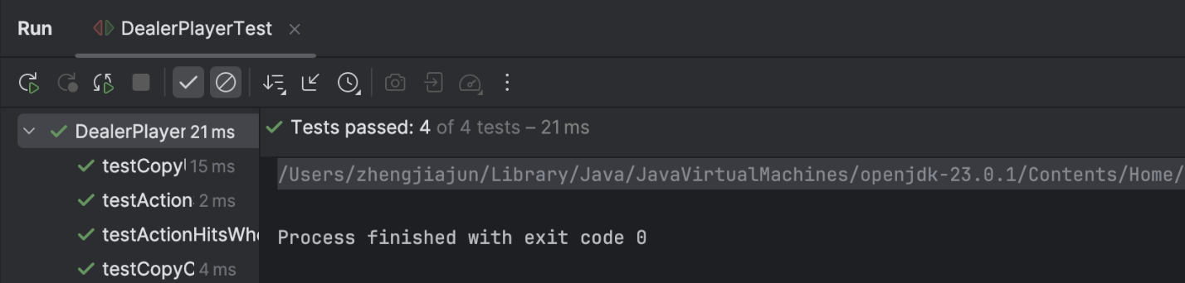
Figure 9. Screenshot of DealerPlayerTest.
BlackJackGameSimulatorTest – Testing full game outcome. The result is shown as Figure 10.
Test Design Goals: Simulate full gameplay with specific card setups.
Test edge cases like: Player Blackjack. Dealer Blackjack. Both Blackjack (Draw). Player busts. Dealer busts. Score comparison leading to win/loss/draw.
Covered Cases: Controlled simulations with known card orders. Game outcome logic without randomness.
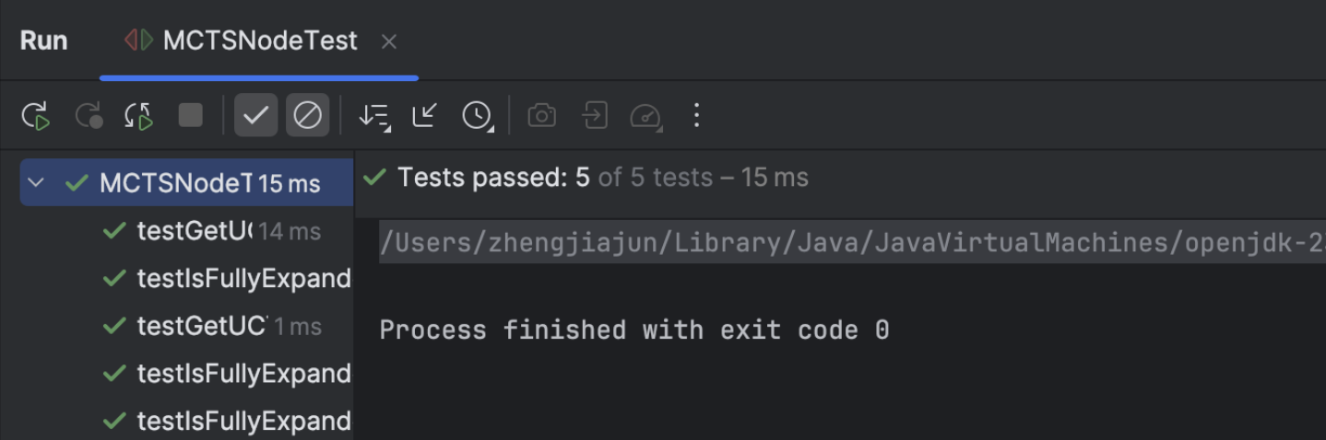
Figure 10. Screenshot of BlackJackGameSimulatorTest.
MCTSNodeTest – Testing MCTS search tree node logic. The result is shown as Figure 11.
Test Design Goals: Validate isFullyExpanded() correctly reflects node expansion state. Check getUCTValue() logic for unvisited and visited cases.﻿ Test UCT value growth under typical simulation conditions.﻿
Covered Cases: UCT calculation when visit count is zero. Normal UCT value updates (wins vs. visits). Children count checks to determine if a node is fully expanded.
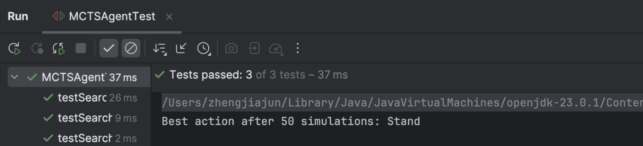
Figure 11. Screenshot of MCTSNodeTest.
MCTSAgentTest – Testing full MCTS decision logic. The result is shown as Figure 12.
Test Design Goals: Ensure MCTS decision-making runs without crashing across different simulation counts. Validate that the returned action is always valid (Hit or Stand). Stress test performance on multiple simulations (e.g., 10–200).
Covered Cases: Sanity check on MCTS rollout results. Action selection after multiple simulations.
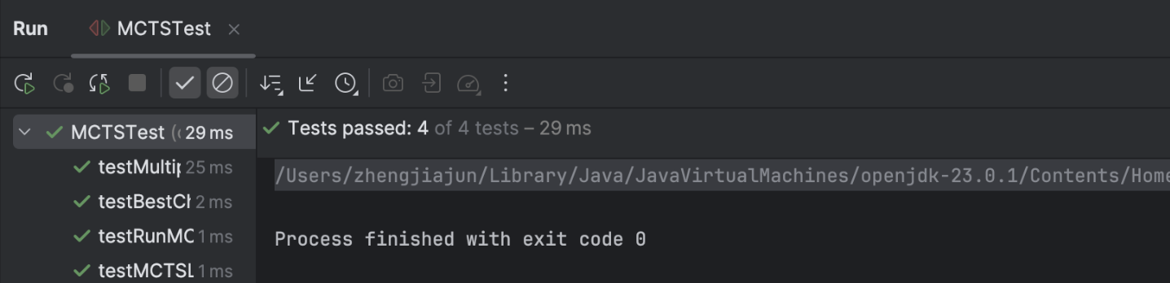
Figure 12. Screenshot of MCTSAgentTest.
No exceptions or invalid state after multiple runs.

  - Optimization
We initially used logic where the deck was shuffled first and then cards were drawn in order. However, this approach resulted in an extremely large number of possible deck states, approximately $\left({52 \atop 4}\right)×48!≈3.36×{10}^{66}$, which is virtually unacceptable for MCTS due to its exponential complexity.
Later, we adopted a strategy that tracks the remaining cards in the deck and draws randomly from them. This reduced the number of possible states to $\left({52 \atop 4}\right)$, significantly improving both the computational efficiency and the accuracy of the algorithm.

  - Data analysis
Observe the impact of simulation times on win rate as shown in Table 1, and plot it as a line graph for analysis as shown in Figure 13.
Table 1. The Influence of Different Simulation Times on Winning Rate
Simulations per Move | Wins (%) | Losses (%) | Draws (%)
10 | 29.32 | 66.64 | 4.04
50 | 36.73 | 58.51 | 4.76
100 | 36.94 | 58.38 | 4.68
200 | 37.47 | 58.09 | 4.44
400 | 37.24 | 58.09 | 4.67
1000 | 37.87 | 57.21 | 4.92
2000 | 38.47 | 57.1 | 4.43
5000 | 38.01 | 57.12 | 4.87

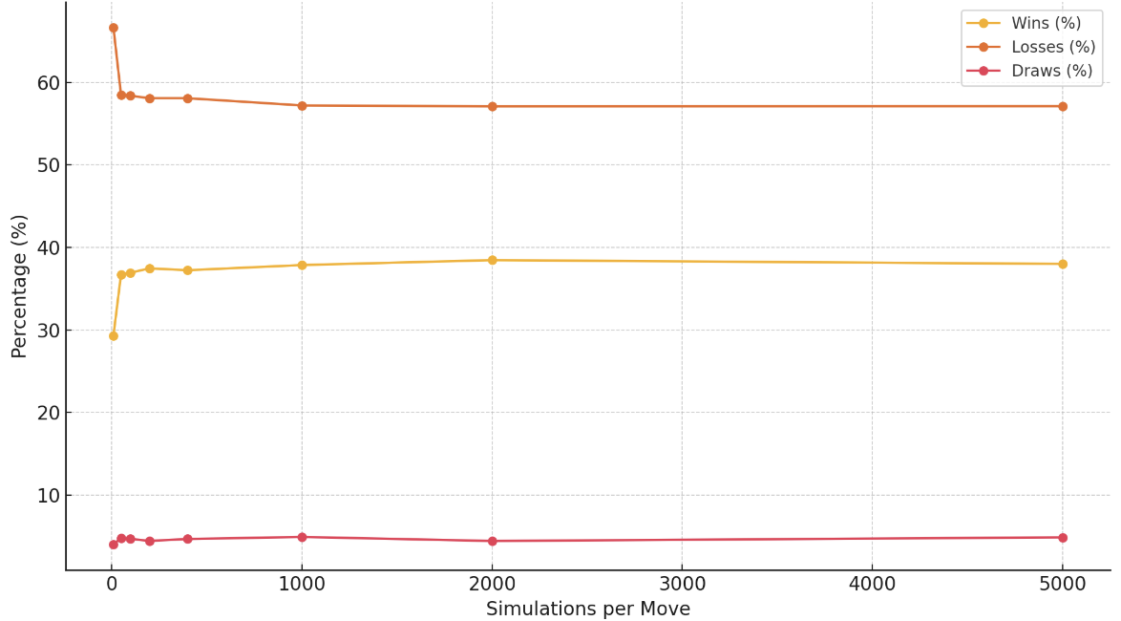
Figure 13. Winning Rate vs Simulation Times
Increasing the number of simulations significantly improves the decision quality of MCTS; The increase in winning rate tends to be saturated, and the growth slows down in the range of 400-1000; If it continues to increase after exceeding 1000, the benefits may not grow as fast as the cost (time) → there exists an "optimal cost-effectiveness" point.
Black Jack's theoretical win rate can be calculated as follows:
$$P(Win) = P(Player not busted \&\& Dealer busted)+P(Player>Dealer \&\& Both not busted)+P(Player Blakjack \&\& Dealer not Blacjack)$$
We can raise the starting card (all two combinations of player and banker). Dynamic programming calculates the transition probability of scores (e.g. the probability from the current 13 Hit to 14~21). Score each path and weight the average. Also we can find that the player has a winning rate of 42% in the classic one-on-one Black Jack problem in Griffin’s Theory of Blackjack^{[1]}. However, in our game, the hands of both sides are completely open, which means there is more information that can be calculated by the banker. Therefore, a win rate of 38% slightly lower than its theoretical value is reasonable.

Observing the impact of game sample size on statistical stability as shown in Table 2, and plot it as a line graph for analysis as shown in Figure 14.
Table 2. The Influence of Different Game Times on Winning Rate
Games | Wins (%) | Losses (%) | Draws (%)
10 | 30 | 70 | 0
100 | 36 | 61 | 3
1000 | 37.2 | 57.4 | 5.4
2000 | 37.15 | 57.65 | 5.2
5000 | 38.76 | 56.94 | 4.3
10000 | 37.98 | 57.06 | 4.96

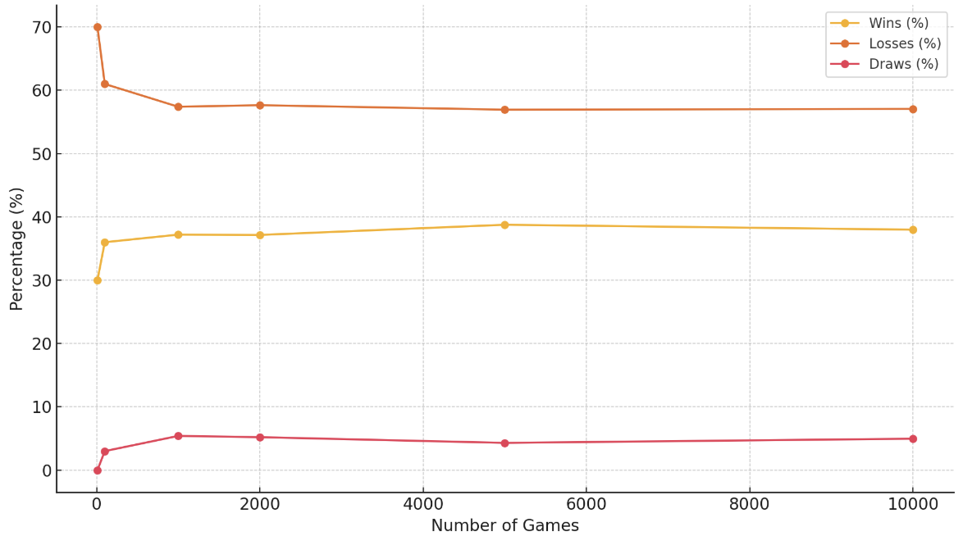
Figure 14. Winning Rate vs Game Times
The statistical results under small sample size are unreliable and may underestimate the winning rate or omit draws. Starting from 1000 games, the winning rate is basically stable and can be regarded as the "convergence zone". The draw ratio is more likely to be reflected in large samples (consistent with probability theory: the probability of a draw is small but not zero).

- Conclusion
In the Tic-Tac-Toe project, we implemented and tested the MCTS algorithm in a deterministic, fully observable environment. The algorithm successfully selected optimal moves, and all unit tests confirmed correct handling of game states, transitions, and winning conditions.
In the Blackjack project, we applied MCTS to a probabilistic setting with hidden information. By redesigning the deck logic to draw randomly from remaining cards, we reduced the state space and improved performance. Simulation results showed that increasing simulations improves decision quality, but with diminishing returns.
While MCTS provides a flexible and powerful search framework without requiring domain-specific heuristics, its performance is sensitive to computational cost. Future improvements could include integrating heuristic-guided rollouts, value function approximations (e.g., via neural networks), or partial information inference to better handle hidden states and reduce reliance on brute-force simulations.

- Reference
1. Griffin, P. A. (1999). The theory of blackjack: The compleat card counter’s guide to the casino game of 21 (6th ed.). Huntington Press.
2. Wikipedia contributors. (2024, April 11). Monte Carlo tree search. Wikipedia. https://en.wikipedia.org/wiki/Monte_Carlo_tree_search
3. Bohg, C. (2019, May 8). Monte Carlo Tree Search: A beginner’s guide. Int8. https://int8.io/monte-carlo-tree-search-beginners-guide/
4. Świechowski, M., Godlewski, K., Sawicki, B., & Mańdziuk, J. (2023). Monte Carlo tree search: A review of recent modifications and applications. Artificial Intelligence Review, 56, 2497–2562.

